Project Report
Name: Mahin Saleem
Task: Web Developer, Task 7
Repository: https://github.com/mahinsaleem001-debug/task1-portal.git
1. Introduction
The task was to build a small responsive web page that works as an internship task portal. The page had to display tasks with their title, description, priority, deadline and status. It also had to support filtering, status updates and basic form validation.
2. Approach
I broke the work into small steps and committed after each one:
- Set up the project, Git and the GitHub repository.
- Wrote the HTML structure (summary, filters, add-task form, task list).
- Added responsive CSS using a mobile-first approach.
- Wrote JavaScript for rendering tasks, filtering, status updates and validation.
- Wrote the README and this report.
- Tested the main workflow on desktop and mobile screen sizes.
3. Technology and Key Decisions
- Plain HTML, CSS and JavaScript: The task is small, so I avoided a framework. This keeps the project easy to run (just open index.html) and easy to explain.
- Separated files: HTML, CSS and JavaScript are in separate files for a clean structure.
- localStorage with mock data: A full backend was not required. Four sample tasks load the first time, and later changes are saved in the browser so they remain after a refresh.
- Mobile-first CSS: Styles are written for small screens first, then a media query at 600px adjusts the layout for larger screens.
- textContent instead of innerHTML: Text entered by the user is displayed as plain text, which prevents it from running as HTML or script code.
- One render function: Every change (filter, status update, new task) calls renderTasks(), so the interface always matches the data and the code is not duplicated.
- Helper function createEl(): It reduces repeated code when creating elements.
4. Features Implemented
- Responsive layout for desktop and mobile
- Task cards with title, description, priority, deadline and status
- Filtering by status, priority, or both together
- Status change between Pending, In Progress and Completed
- Add-task form with validation (title 3 to 60 characters, description at least 10 characters, priority required, deadline required and not in the past)
- Summary counts and overdue highlighting
5. Challenges and How I Solved Them
- Git was not installed. The terminal showed that git was not recognized. I installed Git for Windows and restarted VS Code.
- Wrong repository location. My first push placed the project inside a task-portal sub-folder because Git had been initialized in my user folder. I removed the extra .git folder, initialized Git inside the project folder, and pushed again.
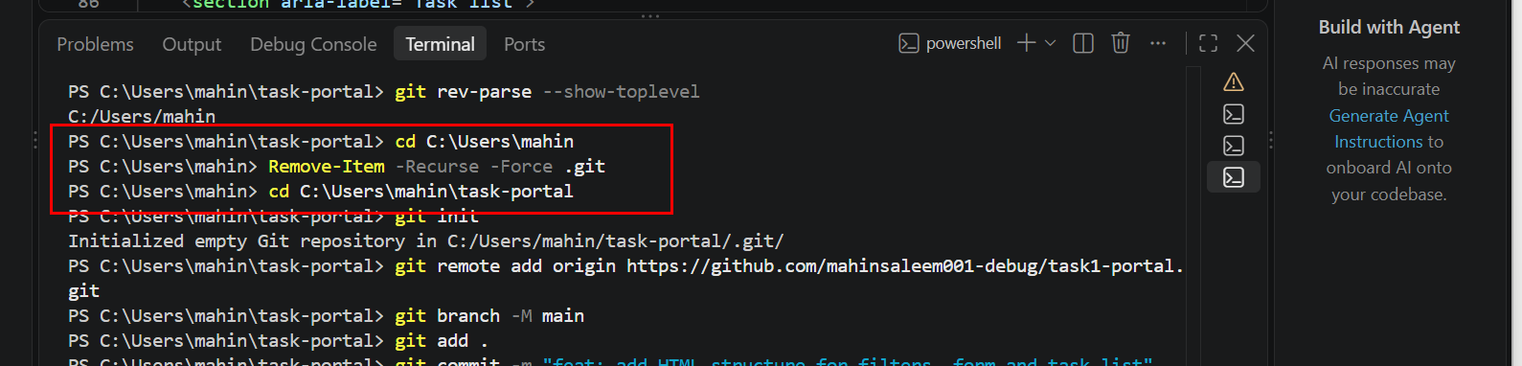
- Commit message error. A missing closing quote stopped the command from finishing. I cancelled it and re-ran it correctly.
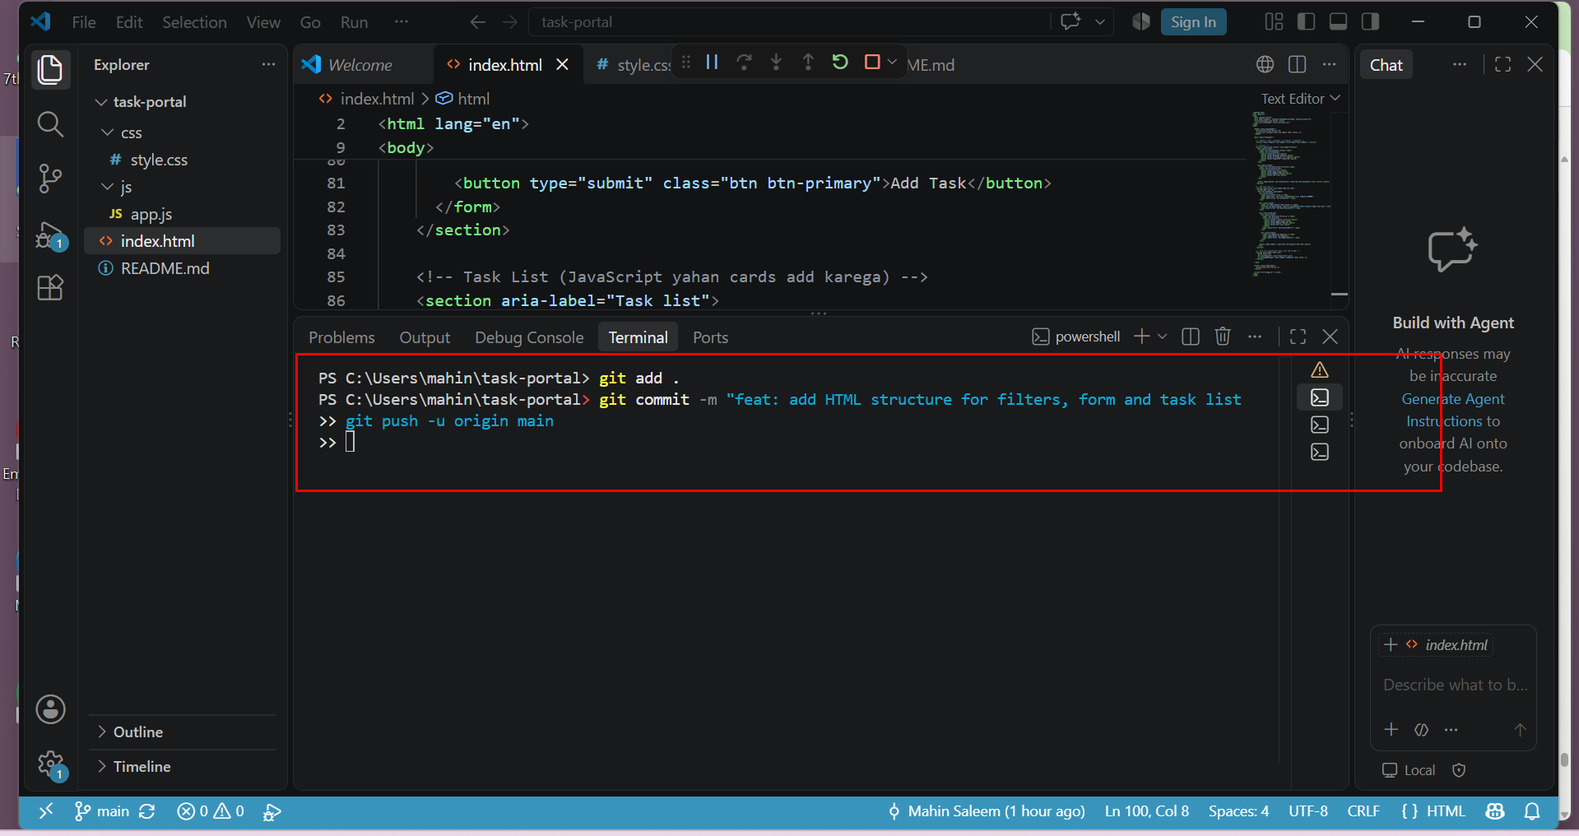
- Unsaved file. Git reported "nothing to commit" because I had not saved style.css. I saved it and committed again.
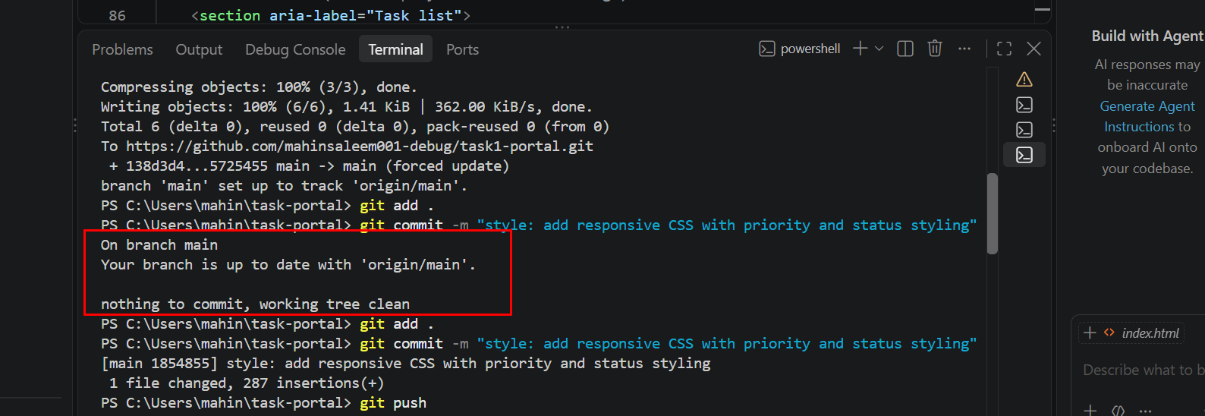
6. Testing
I tested these manually in the browser: tasks display correctly; changing a status updates the card and counts; status persists after refresh; each filter and the combined filters work; an empty result shows "No tasks found."; an empty or invalid form shows error messages; a valid task is added; and the layout works at mobile width.
7. Limitations
- Data is stored only in one browser, with no backend or login.
- Tasks cannot yet be edited or deleted.

8. Future Improvements
- Edit and delete tasks
- Search and sorting (by deadline or priority)
- A backend API and database
- User login
- Automated tests
9. Output
